Sri Lanka Institute of Information Technology



Lab Submission

Lab sheet 07

**IT24104385**

**Rosa S.S.D**

**Probability and Statistics | IT2120**

B.Sc. (Hons) in Information Technology

**1. Exercise**

**Question 1**

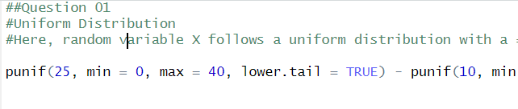

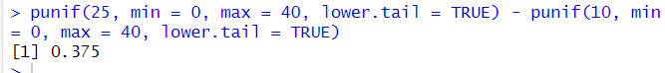

**Question 2**

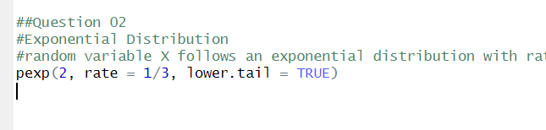



**Question 3**







